AtrExp( CI Game)
Software Installation Guide

Abstract
This document specifies the Installation instruction for Atradius CI Game application AtrExp

Version History
Date | Version | Author | Description
13-11-2015 | 1 | Rajasekaran Jeganathan | Initial draft

Table of Contents
1 Prerequisites 1
2 Installation 1
2.1 Download and install Node.js 1
2.2 Download and install git 1
2.3 Download and install MongoDB 3
2.4 Download and install MongoVUE 3
2.5 Download and install eclipse 4
3 Post-installation Steps 5
3.1 Eclipse git repository configuration 5
3.2 Step to be followed post configuration 5

Prerequisites
Following Software’s are required to proceed Installation in windows.
Software Name | Location | Version
Node JS | https://nodejs.org/en/ | V5.0.0
git | https://git-scm.com/download/win | 2.6.3
MongoDB | https://www.mongodb.org/ | 3.0.7
Mongovue | http://www.mongovue.com/downloads/ | 1.6.9
eclipse | https://eclipse.org/downloads/ | Eclipse Mars.1 (4.5.1)
eclipse plugin for Node Project | http://www.nodeclipse.org/

Installation

Download and install Node.js
Go to http://nodejs.org/ website and select the “install” button (see image below). This should download the version of Node.js you need. For me, when I clicked the “install” the version for Windows 64-bit downloaded. Once Node.js is downloaded, execute the file.
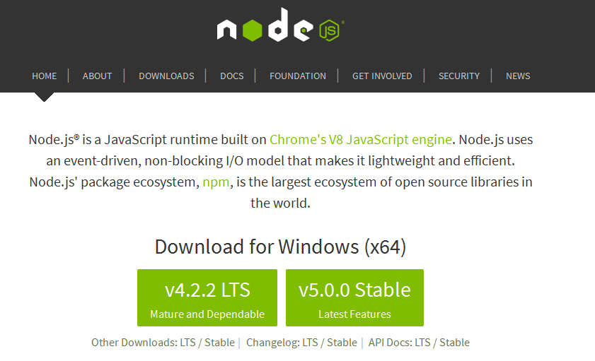

Download and install git
Go to https://git-scm.com/download/win website and select the 64-bit Git for Windows Setup.
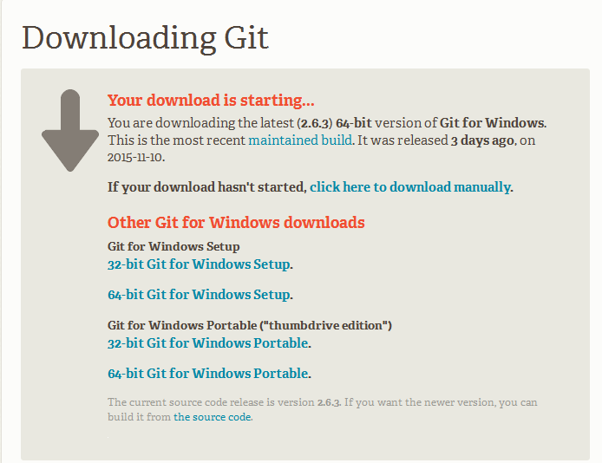
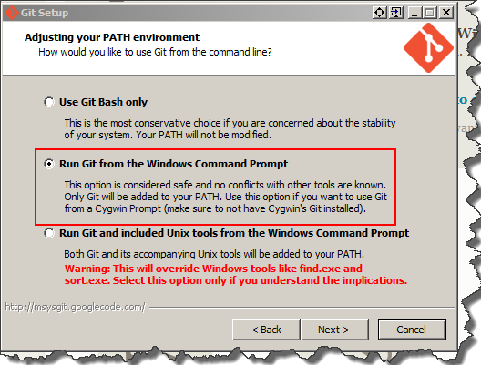

Download and install MongoDB
Go to https://www.mongodb.org/ website and click Download MongoDB.
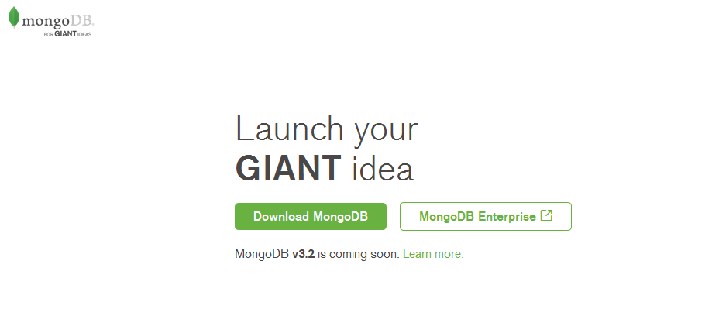
Then click Download(msi).
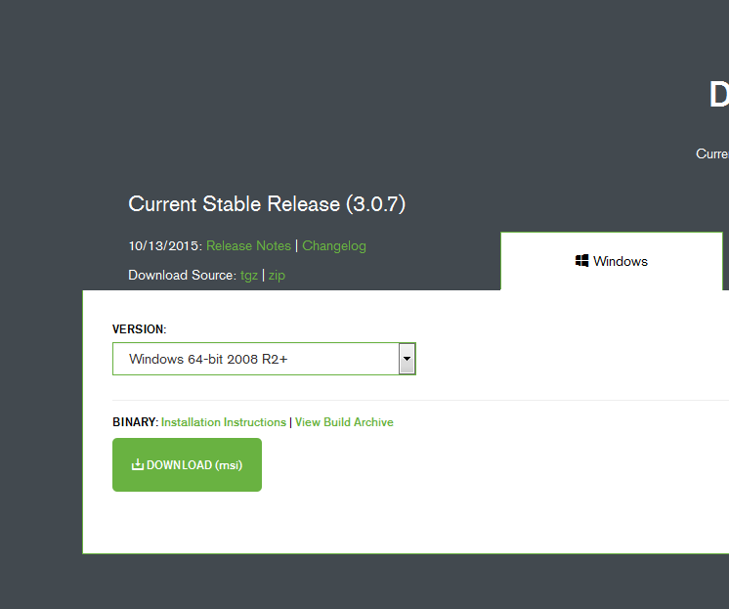

Download and install MongoVUE
Go to http://www.mongovue.com/downloads/ website and click Download. Once MongoVUE is downloaded, execute the file.
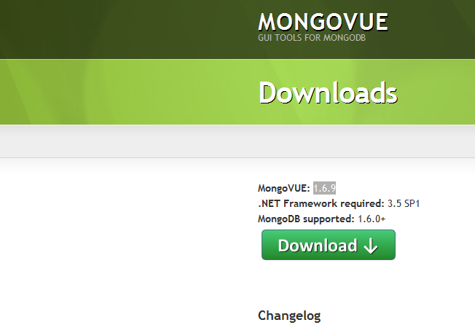

Download and install eclipse
Go to https://eclipse.org/downloads/ website and click Download. Eclipse is downloaded, execute the ecplise.exe file. Then install nodeclipse plug-in from http://www.nodeclipse.org or from eclipse market place.
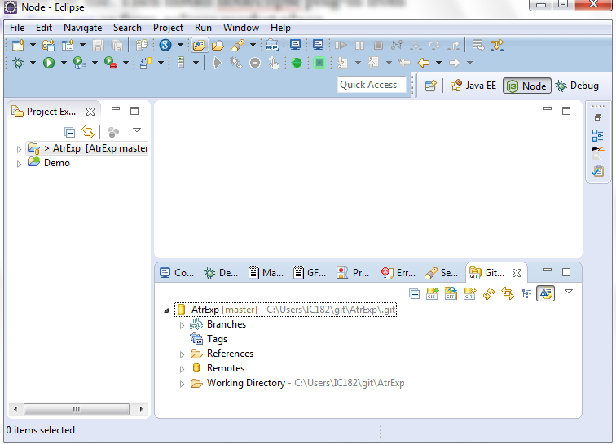

Post-installation Steps

Eclipse git repository configuration
How to configure project in to eclipse from github . Please refer following link for more details.
https://wiki.eclipse.org/EGit/User_Guide#Cloning_a_Repository_2

Step to be followed post configuration
Open git command prompt and go to AtrExp project path then execute following command.
- npm install
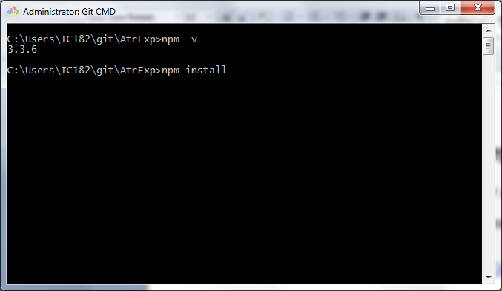

- npm install -g grunt-cli
- npm install –g bower
- bower install
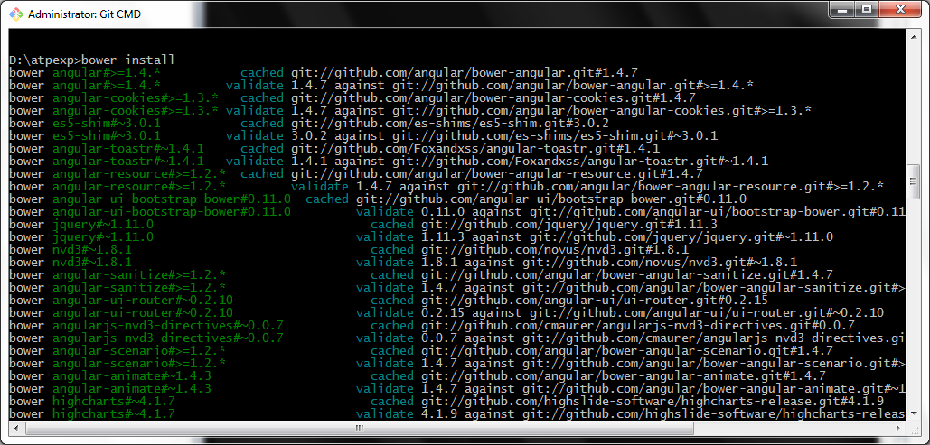

- Start mongodb
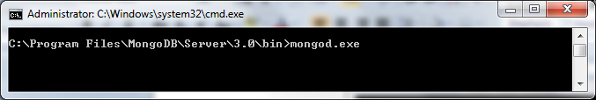
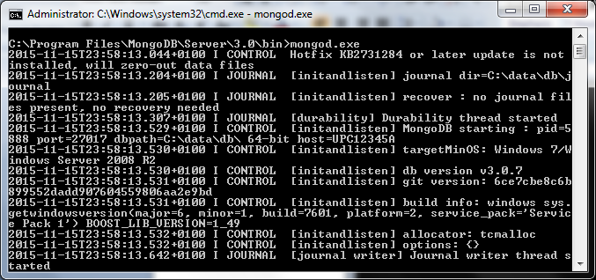
- grunt build
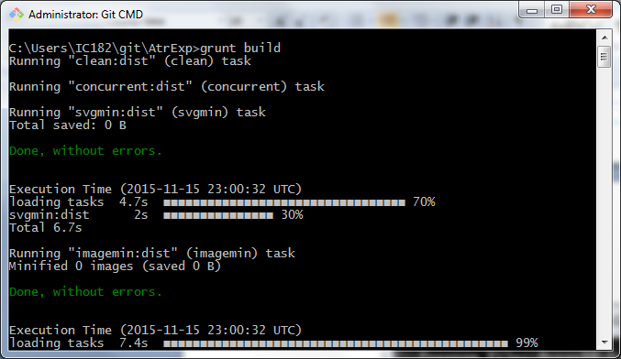
- grunt serve
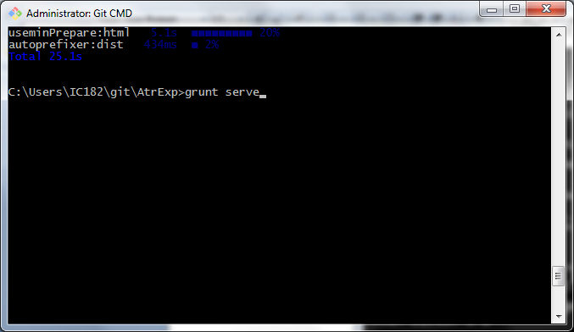
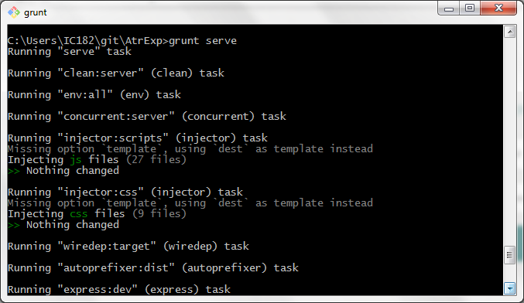
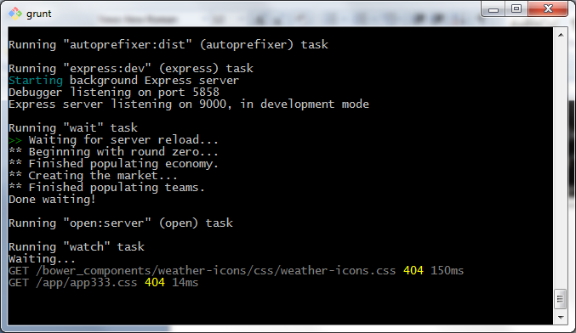
After browser will open login page automatically.
